Glasgow University
Students’ Representative Council

PGR Representative Training Handbook
2016-17

Introduction

Thanks for getting involved and thank you for signing up to be a PGR representative. The representative role is really valued at Glasgow and in Universities throughout Scotland and this booklet – together with the Introductory training session – is the first step in giving you an understanding of your new role.

Accreditation on your transcript (Higher Education Achievement Report)
There are some criteria you must fulfil to have your time as a rep accredited on your transcript:
1. Attend one of the Introductory Level training sessions
2. Fulfil your role as a PGR rep during your time in office
3. Complete a short questionnaire towards the end of the year, reflecting on your time as a representative.

Introductory Level Training
As well as organising the training sessions (which are repeated in semester two for anyone who missed them in semester one), Glasgow University Students’ Representative Council (GUSRC) will provide you with on going support during your time as a rep.

This booklet and the training have been created by GUSRC in partnership with an agency called sparqs (student participation in quality Scotland) in order to increase the effectiveness of the student representatives. in working with the University to improve the learning and research experience at Glasgow. We do this because we believe that students should have the skills and knowledge which enable them to be at the heart of the drive to enhance and improve the teaching and learning at University. The key aim, therefore, is to work with the University to improve the learning and research experience at Glasgow.

The introductory training will develop your understanding of what it means to be PGR representative at Glasgow University. It will:

- Introduce the skills needed to be effective in your role
- Help you understand the university’s structures and mechanisms for student engagement and representation, so that you know how to work within these to represent student opinion
- Give you the chance to meet other PGR representatives, and find out more about the new ways in which you can connect with other students in the postgraduate community this year.

The training is interactive and discussion based and will last approximately 2 hours.

GUSRC will issue you with a certificate to confirm you have completed the training.

The term PGR Representative has been used throughout this booklet and is the equivalent of ‘class representative’ in the undergraduate and PGT courses.

The booklet is designed so that you can take notes in it during the training. It can also be used as a reference during your time as a rep.

Enjoy your training and good luck!

Exercise 1 – Your area of research

In this exercise we want you to start thinking about your research environment and the positive and negative elements of it. There is space below to answer some questions:

How might the research environment be improved for students like you?
What do you like most about the research environment in your School or Research Institute?
What is your area of research?
Exercise 2 – Your representative role

The purpose of this exercise is to get you to start thinking about the purpose of the PGR rep; what you will be doing as a rep; what are the skills you will need and finally what the benefits are.

What do you think some of the tasks will be?
What do you think the purpose of the student rep is?
How do you think being a rep will benefit you?
What skills do you think you will need and develop as a rep?
The role of a PGR Representative
As a PGR representative you play a crucial role in the way your learning experience, research environment, school, and the University itself are shaped. As current students, you and the others on your course are the experts at being able to comment on the learning and teaching that you are receiving, and as the representative it’s you who puts that comment and opinion forward.

As a PGR Representative your purpose is to:

- Help create solutions to problems
- Represent your fellow students’ views and opinions on all matters relating to learning and teaching/supervision and the research environment
- Provide both positive and negative feedback to staff
- Act as a communication channel between staff and students.

Some of the tasks will include:

- Introducing yourself to students you are representing
- Gathering student opinion
- Providing feedback to staff and students and closing the feedback loop
- Attending meetings with staff in your School. This forum allows you to speak directly to staff and take an active role in shaping the future of your course.
- Speaking to people outside of the meetings
- Reading documentation e.g. minutes
- Presenting students’ views at meetings
- Developing solutions to issues
- Passing issues on to GUSRC via PG Convenors or College Convenors
- Contributing to institutional activities

You will need/develop the following skills:

- Communication/Listening
- Networking/Relationship Building
- Reflection/Analysing/Problem Solving
- Presentation
- Organisation/Time Management/Prioritisation
- Report-writing
- Diplomacy/Negotiation/Influencing
- Research

The benefits to you could include:

- Researcher development – experience and skills valued by future employers
- Networking opportunities
- Background for any future representational roles
- Wider knowledge of the institution and current issues in higher education
- Validation on your student transcript (Higher Education Achievement Report)

As a PGR representative your main aim is to raise any points regarding a specific area of study or aspect of the research environment. If you have an issue regarding the wider experience of being at the University, for example: lack of car-parking, lack of facilities across campus, complaints about the dining facilities or anything similar, then please raise these with the Students’ Representative Council, as they deal with the entire student experience, whereas the staff in your School will only be able to resolve School issues. You can contact GUSRC via your PG or College Convenor, or contact GUSRC directly (see www.glasgowstudent.net).ls).

The Vitae Researcher Development Framework

Many of the skills you will use and develop as a rep (listed on the previous page) can be mapped onto areas of the Vitae Researcher Development Framework, below. For more information about the RDF, please visit the Vitae website at www.vitae.ac.uk/researchers-professional-development/.

Some Graduate Schools may give training credits for your work as a rep. Check with your own Graduate School if you are unsure.
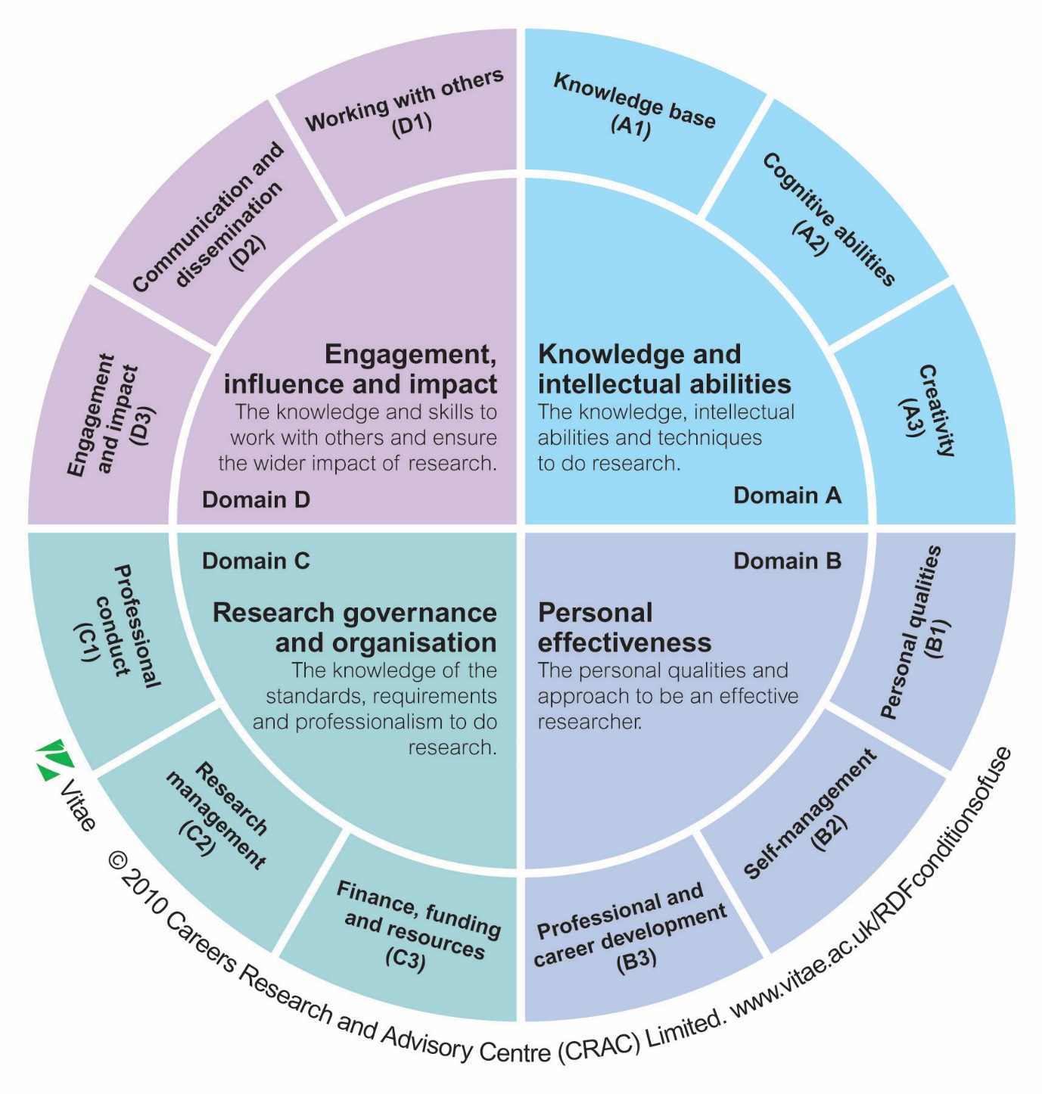
Why PGR Representatives are important

Any student undertaking the role of a representative at Glasgow University is there to make a difference to the learning and/or research experience that they and the people in their subject area receive. By this we mean that you have a chance to comment directly on the things that affect the way you learn and how you are taught (you, and your fellow students, are the experts!). By speaking to other people in your area of study, and being representative of their opinion, you will gain a cross-section of opinion that you can feed into the staff in your School. This will enable them to continue to develop and improve the course or research provision.

What does the University expect?

The University expects you to act as a representative for your fellow students – not just follow your own agenda and interests. You therefore need to make sure you consult appropriately, and report back to students. GUSRC and the University have forged a good working relationship over the years and have found that discussion and negotiation, rather than confrontation, is often the key to getting things done. Be clear on your goals and consider potential compromise solutions. Lastly, don’t forget to let the University and GUSRC know what you’ve thought about being a rep, as this will help to improve the system for future representatives.

The Learning and Development Experience

The learning and development experience is made up of different elements relating to the overall experience. Asking a fellow student to tell you about their whole learning experience may not get the response you are looking for. Breaking it down into different elements, such as those in the diagram below, will help you gather the positive and negative feedback so you can inform staff what they are doing well and where they can improve.

GUSRC and sparqs have developed some questions to ask your fellow students that will help you gather the feedback you need. They are grouped under each element of the student learning and development experience. No doubt you will be able to think of other questions in these areas – these are just some ideas to get you started.

Thesis Topic/Research Project
- Are you in contact with other students researching topics similar to yours?
- Have you been able to research the topic you wanted to?

Resources & Infrastructure
- Are there adequate library and computing facilities in your School?
- Do you have access to materials you need (e.g. books, lab equipment, art materials)
- Did the School’s facilities meet your expectations?
- Can you access resources when you need to?

Guidance & Support from Supervisory Team
- Is academic support readily available?
- Are you aware of who your support contacts are, within and outwith your subject area?
- Did you receive sufficient information during your induction?
- Have you received training in any practical skills necessary for your research?
- Are you satisfied with your supervision?

Assessment & Feedback
- Are assessment criteria clear to you?
- Are you given enough time to prepare for assessments?
- Do you receive adequate and timely feedback on submitted work?
- Do your supervisors meet with you regularly to discuss your progress?
- Is the feedback you receive useful/constructive?
- Is the frequency of assessment helpful to you?

Progression & Achievement
- Do you feel you are learning/improving/making progress?
- Are you aware of the requirements to progress to the next year of your research?

Personal & Professional Development
- Are you encouraged to develop your skills and experience?
- Are you aware of resources and opportunities available to help you do this?
- Are the resources/opportunities appropriate/sufficient?
- Are you given opportunities to progress to an academic career?
- Do you feel you are developing skills for a career outside of academia?

Quality Assurance & Enhancement
- How do you feel your institution compares with others?
- Do you feel your School is receptive to concerns?
- Do you feel that your opinions are listened to and taken seriously?
- What improvements have been made to the research environment in your School?
- Do you feel that your research experience has been of an acceptable standard so far?
This diagram shows the SSLC right at the heart of the process, receiving inputs from student feedback and graduate school review.

Outcomes from the SSLC are shown being fed back to staff and students (left and right), and considered further for appropriate action (which could be at subject, school, programme or even institution level, depending on the issue).

This process is evidence that quality enhancement is happening (pink layer) which in turn informs the review processes known as REF and ELIR (which we will come on to shortly). These review processes are very important for the University’s reputation and continued funding.

It is clear from this that a stone thrown into the SSLC pond can create very widespread ripples indeed.

Glasgow University Students’ Representative Council

The core aim of GUSRC is to facilitate the representation of students' views within the University of Glasgow. GUSRC is made up of staff and students who are there to ensure this happens effectively. As well as this, GUSRC provides a range of services from the advice centre to photocopying facilities and second-hand bookshop, and offers volunteering opportunities in community projects and student media (see www.glasgowstudent.net).

As demonstrated in the diagram above, SRC officers sit on many important Committees throughout the university and represent the entire student-body opinion at these meetings.

GUSRC deals with the entire student experience, this includes: social and recreational aspects of uni life, academic life, facilities or lack of, transport to and from university, fees and other financial aspects and advice on everything from housing, to money, to appeals, complaints and student conduct issues. Over time they may also be in contact to get your input or opinion about a range of topics and your input into this is vital so that your SRC can truly represent you.

If you have any queries or issues relating to the above topics please contact or visit the SRC and speak to a staff member or student officer.

Quality Enhancement at the University of Glasgow

This diagram is simply to give you some information on the various quality assurance/enhancement processes that operate within the University, and are relevant to the PGR experience.

SSLCs, Annual Monitoring and Graduate School Reviews are all internal to the University, occurring at differing intervals as you can see here.

ELIR, or ‘Enhancement Led Institutional Review’ is an external review, every 5-6 years, which covers the whole of the University, and is taken into account by the Scottish Funding Council in making funding decisions for the future.

The REF, or Research Excellence Framework, is a new review, replacing the previous Research Assessment Exercise. The first REF took place in 2014, and the research environment contributes 15% to the REF score. The University was also asked for information about research degrees awarded, strategy and infrastructure, research student population and so on.

Communicating effectively

As the representative you will need to speak to the other students that you represent to gauge their opinions and comments. We appreciate that this can be time consuming and challenging, particularly if you are representing a lot of people. Sometimes the easiest way to gain opinion from others is to simply keep your ear to the ground and try and pick up on the general feelings. If people in your subject area really like or dislike some aspect of the course, be it a supervisor’s style, access to resource materials, induction, assessments, arrangements for supervision etc, then people are likely to vocalise it!

Communicating to large groups:
- Speak to your friends first if it would make you more comfortable, then approach the others in your area of study.

- Listen out for what people are saying when you are in an informal setting, i.e. before or after a class or if you are sitting with fellow students at lunch or over a coffee (use the Gilchrist Postgraduate Club!)

- Generally labs and seminar groups are split into smaller groups of students and you could ask the supervisor/tutor if you could take a few minutes to speak to people in this setting.

- Use the new Student Voice website to generate discussions and keep in touch with the students you represent and other PG reps.

- Use other social media (e.g. facebook/twitter) or email to encourage people to use the Student Voice website and let them know when there’s an update to something on the site.

Communicating with everyone is not always easy. People will find it easier to talk about aspects of their environment that they don’t like but may find it hard to say how things could be improved. It is also important to remember that some people are more vocal than others, that some may have language difficulties, others will lack the time to give you feedback and some will simply be at a loss for what to say about their learning and development experience.

It is a good idea to assure your fellow students that any comments or opinions that you put forward will remain anonymous and that you will not personally name anyone.

Student Voice

The University has been developing this for a few years now, and it’s important to really make the most of it – as PGR reps you will be key to making it work!

Student Voice is accessed through the MyGlasgow portal (the same way that students access webmail, MyCampus, etc). The aim is to make the experience customised to the user, so that each student will view information about their own subject area, School, College and the University, without having to wade through irrelevant information about other courses.

PGR reps can communicate directly with the students that they represent. As PGR rep, your contact details will be prominent for students to see, and there will be contact details for the relevant SRC Postgraduate Convenors and College representatives too.

We hope that you will use this tool yourself and encourage other students to use it by starting discussion topics on the forum and regularly checking in with the site to contribute to discussions and give and receive feedback on your representative activities. Online communities like this are particularly important for keeping in touch when you are not in regular classes with other students that you represent.

There will be an ‘Issue Tracker’ so that you can keep your fellow students updated on whether an issue is Resolved, In Progress, or has been Cancelled for whatever reason.

Students will be able to see at a glance on their MyGlasgow whether there have been any updates or recent activity in Student Voice.

As a representative, this is your chance to take the lead on this exciting new development, and show students how to get the most out of it.

Providing feedback is an essential part of being a rep, but how do you provide it effectively? Sparqs has developed the ABCD of effective feedback to help you do so. The elements are as follows:

Accurate: When commenting on the learning experience, be specific, and provide evidence for what you are saying. Avoid sweeping generalisations or emotional language. If you have a survey that tells you that 67% of people don’t like the feedback they receive, don’t tell staff that “nobody likes it”.

Balanced: Don’t just pass on negative comments to staff, even if that is mostly what you are hearing from students. Say positive things too. This helps soften the blow, staff are less likely to feel defensive and reject your suggestions out of hand, and it makes you look more professional too.

Constructive: You are not just here to identify problems, you are also here to help find a solution too. If you raise an issue, make a suggestion at the same time.

Depersonalised: Even if students think that a member of staff has done something wrong, it’s always hard to make or receive personal comments. Try not to comment on the demonstrator or supervisor, but talk simply about the impact on your learning experience. (If there are grounds for complaint about a supervisor on an individual level, this is best taken up outwith the SSLC format. The SRC advice centre can provide guidance on this if required.)
Exercise 3 – Gathering Student Opinion

Look back to Exercise 1 and think about the improvements you thought could be made to your research environment. Now think about how you would find out whether or not your fellow students agree.

There is space below for your notes.

Exercise 4 – Developing Solutions

Using your idea for improvement from Exercise 3, in groups, develop a solution to this issue. You need to think about:

- What resources the staff have access to
- How realistic your solution is
- How creative your solution is
- The ABCD of effective feedback

There is space below for your notes.

Exercise 5 – Getting your issue fixed

Now that you have developed your solution you will need to think about how you are going to get your issue fixed. Unfortunately, there are no student-staff meetings for four months. What are you going to do?

There is space below for your notes.

Attending Staff-Student meetings

As a representative you will be required to attend at least two meetings within an academic year. These meetings will differ between Schools and Colleges. The aim of these meetings is to get PGR representatives and staff from each School to discuss the general learning and research experience.

A member of staff within your School will be able to give you the specific information and dates for the meetings that you are attending. If you are unsure who this is, ask at the School office and they should be able to point you in the right direction.

Meeting Checklist:

Before
- Where and when is the meeting going to take place?
- Find out what your fellow students think about their learning/research experience.
- Each meeting will have a Chair and Secretary present, if possible you should find out who these people are before you attend a meeting, and it’s a good idea to meet with the Chair beforehand if you can. You will have the opportunity to chair the meetings if you want to, supported by a member of the academic staff.
- Is there anything you want to put on the agenda? Get in touch with the Chair/Secretary.
- Read the papers that have been sent round. You should be sent any paperwork in advance e.g. the agenda, minutes of the previous meeting and any other information that you will be discussing at the meeting.
- Speak to other reps

During
- Always be on time, if you are going to be late let the Chair/Secretary know before the meeting.
- Take a pen and paper for notes.
- Sit where the chair can see you and raise your hand to indicate you want to contribute.
- Remember the A, B, C and D of effective feedback.
- Ask questions if you do not understand anything. If there’s something you don’t understand, the chances are there’s someone else in the room who doesn’t understand either.
- Support other reps in the meeting.
- Minutes may not be issued until a wee while after the meeting. It’s a good idea to note down any action points so that you can get started on them as soon as possible.

After
- Report back to the students that you represent.
- Check the minutes.
- Do anything you have been asked to do.
- Follow up any areas of concern.
- Did you achieve what you wanted to achieve? If not what are you going to do about it?

Working with the staff at University of Glasgow

Because you will only attend 2 or 3 meetings a year you may find that it’s helpful to pass on issues outside of proposed meeting times, this will allow you to get issues dealt with quicker.

It might seem obvious but it’s worth stating: the University staff are the people that get you through your degree. Many staff will inspire you, expand your knowledge, make learning interesting in subjects you never thought you’d be interested in and may even cut you a little slack when you need it.

When dealing with staff members there are some key points to be aware of, particularly if you are raising a problem or issue about something they have done (or not done):

  - Be clear and concise in what you want to say
  - Think about what you are hoping to achieve from raising a particular issue
  - Most staff will be happy to listen to you but be conscious of their time. They are busy people too
  - Be diplomatic
  - If you are raising a concern about an individual member of staff make sure you speak on behalf of everyone you represent, and be reasonable about how you convey a problem.

As well as attending meetings you have a range of other ways that you and your fellow students can have a say about your education. For example:

- Feedback forms/annual monitoring
- During networking events or seminars arranged by your School
- You may be invited to attend a focus group about your University or School
- Through annual Institution-wide surveys
- Surveys and questionnaires produced by the Students’ Representative Council

If you are unsure how feedback is used to make improvements to your particular area of study, then please ask the Chair of the Staff Student Liaison Committee or Graduate School Board, who will be able to tell you how student feedback and opinion has been used over the past year.

Closing the feedback loop

Resources and Contact Information

GUSRC website

www.glasgowstudent.net/about/representation/class-reps

Student Voice

www.gla.ac.uk/students/myglasgow

Senate Office website

www.gla.ac.uk/services/senateoffice/qea/studentengagement/studentrepresentationstudentvoice

sparqs

www.sparqs.ac.uk

Thank you for attending Introductory Level PGR rep training. We hope you have a good year as a representative and that you are able to make improvements to your area of study as well as improving your own skills and gaining new experience.

Appendix One – Some Common Abbreviations

AoS | adviser of studies
ARSC | academic regulations subcommittee
ASC | academic standards committee
CAoS | chief adviser of studies
CoA | code of assessment (found in the university calendar)
CRB | central room bookings
DoGS | dean(s) of graduate studies
EdPSC | education policy and strategy committee
ELIR | enhancement led institutional review
GA | graduate attributes
GTA | graduate teaching assistant
HEA | higher education academy (www.heacademy.ac.uk)
ISB | international student barometer (twice-yearly survey)
KIS | key information set (information on every HEI published on a national website)
KPI | key performance indicator
LTC | learning and teaching committee
LTDF | learning and teaching development fund
MSA | mature students association
NSS | national student survey (final year students take part in this)
NUS | national union of students (UoG is not affiliated to NUS)
PAG | programme approval group
PGR | postgraduate research (e.g. PhD)
PGT | postgraduate taught (e.g. MSc)
PIE | parents’ information event
PRES | postgraduate research experience survey
PSR | periodic subject review
PTES | postgraduate taught experience survey
QAA | quality assurance agency (www.qaa.ac.uk)
QEF | quality enhancement framework
QOF | quality officers’ forum
RDC | researcher development committee
REF | research excellence framework
RIO | recruitment and international office
RLUK | research libraries UK (www.rluk.ac.uk)
RPSC | research planning and strategy committee
RWG | retention working group
SFC | scottish funding council
SLS | student learning service
sparqs | student participation in quality scotland (www.sparqs.ac.uk)
SSDC | student support development committee
SSLC | staff-student liaison committee
STEMM | science, technology, engineering, maths and medicine
TEA | teaching excellence awards (staff-led scheme)
VCS | volunteering, clubs and societies
VLE | virtual learning environment (e.g. moodle)
WP | widening participation

